LinkedIn Posts (by author)
- Russell Brunson
https://www.linkedin.com/posts/russellbrunson_you-dont-need-to-be-the-loudest-or-the-activity-7471038069186441216-epoU?utm_source=share&utm_medium=member_desktop&rcm=ACoAABj3toIB7xQ4n7AK-Epu3xGMoPS5JU4Svgs
Posted on 12th June 2026:
"You don’t need to be the loudest.
Or the most polished.
Or the most “viral.”
You need consistency.
Show up and talk about what you're building.
Even when it feels repetitive.
Even when no one is clapping.
Even when you're not sure it's working.
Because visibility builds trust.
And trust builds momentum.
Every. Single. Day.
That’s how you grow."

- Jason Fladlien
https://www.linkedin.com/posts/jason-fladlien_why-i-skip-conspiracy-in-my-marketing-activity-7470557985740570625-CuKm?utm_source=share&utm_medium=member_desktop&rcm=ACoAABj3toIB7xQ4n7AK-Epu3xGMoPS5JU4Svgs

Posted on 11th June 2026:

Why I skip conspiracy in my marketing

- Amy Porterfield
https://www.linkedin.com/posts/amyporterfield_you-cannot-out-hustle-a-nervous-system-that-activity-7470927854508167168-meVJ?utm_source=share&utm_medium=member_desktop&rcm=ACoAABj3toIB7xQ4n7AK-Epu3xGMoPS5JU4Svgs

Posted on 11th June 2026:

You cannot out-hustle a nervous system that doesn't feel safe.
A dysregulated CEO will always find a way to slow her own growth down.
Not because she isn't capable, but because her body is trying to protect her.
I made a new coaching video about this and my friend, it might be the most important thing you watch this week.
Watch here: https://lnkd.in/dehbyxWV

- Jon Schumacher

https://www.linkedin.com/posts/jonschumacher_ai-can-commoditize-premium-consultants-activity-7470882566087221249-YaWe?utm_source=share&utm_medium=member_desktop&rcm=ACoAABj3toIB7xQ4n7AK-Epu3xGMoPS5JU4Svgs

Posted on 11th June 2026:
AI can commoditize premium consultants.
I know because I let it ruin my positioning this spring.
I have advised Shark Tank startups, billion-dollar corporations, and over 2,900 consultants worldwide.
I am the #1-ranked webinar consultant on Google.
Yet, a few months ago, I fell into a classic marketing trap.
I over-indexed on AI.
My history with AI isn't new.
In late 2022, I secured early API access and built AI-powered sales systems that sold well through 2023, 2024, and 2025.
Emboldened by that success, I spent a small fortune developing a brand-new AI software platform for this year.
I expanded the scope to automate everything: webinars, emails, social content, and closing scripts.
I launched it this spring. The results were less than optimal.
Despite my years of experience, I made two fatal mistakes.
First, my messaging became too focused on AI and the software tool rather than my unique expertise and the specific outcomes it helps people achieve.
Second, I expanded my promises too broad instead of sticking to my core trust-building webinar system.
Premium B2B clients and high-net-worth individuals do not buy software features or broader toolkits. They buy certain outcomes.
When we hide our intellectual property behind an AI wrapper, we invite prospects to compare us to cheap frontier models.
You inadvertently commoditize your own genius and positioning.
AI is an exceptional asset for your backend delivery stack, but it should never replace the front-facing authority that commands premium fees.
Your expertise is the premium asset.
AI is simply one of the mechanisms that delivers it.
Be careful over-indexing on it.

- Anik Singal

https://www.linkedin.com/posts/aniksingal_everyone-is-talking-about-ai-tools-new-activity-7470795318364770305-ve45?utm_source=share&utm_medium=member_desktop&rcm=ACoAABj3toIB7xQ4n7AK-Epu3xGMoPS5JU4Svgs
Posted on 11th June 2026:
Everyone is talking about AI tools.
New features.
Faster answers.
Smarter outputs.
And yet…
Most people are still using them like search engines.
They scratch the surface,
but never change how they actually work.
So they conclude:
“AI is useful… but not game-changing.”
But the tool isn’t the problem.
The usage is.
Here’s what’s actually happening.
People focus on what AI can do,
instead of how to integrate it into their workflow.
They try one-off prompts instead of building repeatable systems.
They search faster,
but don’t think better.
The shift isn’t from Google → AI.
It’s from searching → operating differently.
Look at what tools like Perplexity actually enable:
→ Real-time answers with sources
→ Deep multi-source research in minutes
→ Asking questions directly on your own files
→ Comparing ideas, tools, and decisions instantly
→ Turning news, papers, and data into usable insights
→ Building a personalized knowledge system over time
That’s not a feature upgrade.
That’s a workflow redesign.
The people getting real leverage aren’t using more tools.
They’re using one tool… differently.
They’ve moved from:
→ Searching → Synthesizing
→ Consuming → Deciding
→ Asking → Iterating
That’s the shift from information access to intelligence leverage.
And it’s not a tool skill.
It’s a thinking skill.
Here’s what most people miss:
AI doesn’t reward curiosity alone.
It rewards structure.
If you don’t change how you ask, organize, and apply nothing changes.
So the real question isn’t:
“Which AI tool are you using?”
It’s:
“Have you changed how you think and work with it?”
Because that’s where the compounding starts.
♻️ Repost if you see people using AI… but not leveraging it.
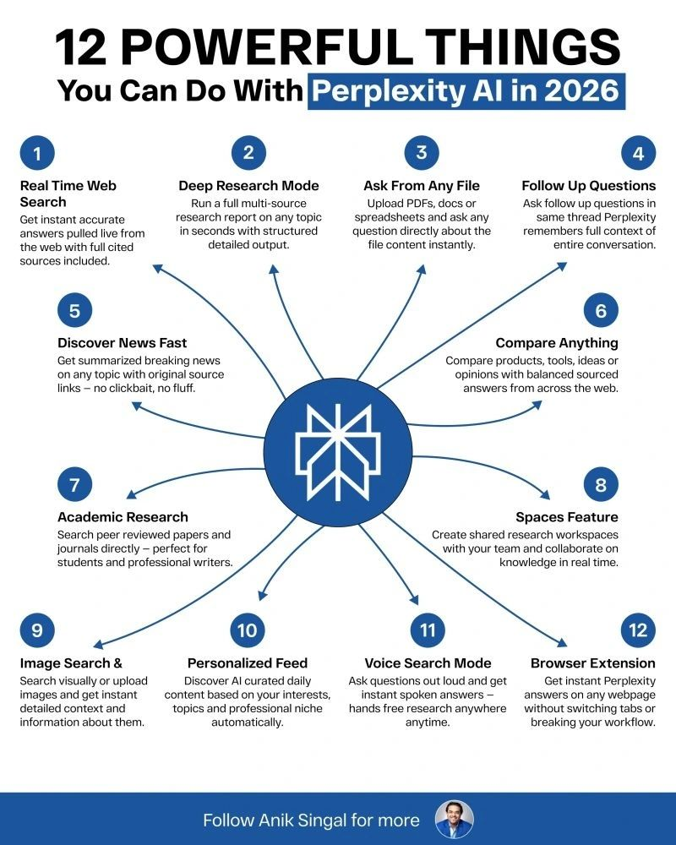

- Melissa Kwan

https://www.linkedin.com/posts/melissakwan_the-question-that-always-breaks-the-internet-activity-7467926826288386048-7Qn_?utm_source=share&utm_medium=member_desktop&rcm=ACoAABj3toIB7xQ4n7AK-Epu3xGMoPS5JU4Svgs

Posted on 5th June 2026:
The question that always breaks the internet: can money buy happiness❓ 💰
I had a chat with Simon Swords, who bootstrapped Fundipedia for 20 years before selling it for a life changing exit last year.
While our journeys are very different, I recognized a lot of my own struggles in his. The hustle, sleepless nights... anxiety of not knowing where it's all headed. The chip on my shoulder, wanting to prove my worth through external achievements, then realizing none of that actually matters.
The day his deal closed, Simon had what he called "a big old cry." He told me it wasn't relief. It was 25 years, maybe 42 years, of pain, self loathing, and overthinking everything finally letting go.
The money landed, but the anxiety didn't leave.
He said something that stuck with me. "Once you have money and options, you're not allowed to be sad." Your friends are still working. Everyone expects you to be living your best life. So you smile and nod and keep most of what you're feeling to yourself.
I didn't end up asking Simon if he thinks money can buy happiness, because I already knew what he was going to say.
But something clicked for me in that moment that I couldn't put into words before. I've always believed money can buy happiness, because it has afforded me extraordinary experiences and allowed me to live life on my terms. I believe that to have financial success, you have to have a positive relationship with money.
I realized that while money might be able to buy you happiness, it can't make you "not sad." That is something entirely different.
We all have this idea that once we get to the destination, everything will be great. Once we have $10m in the bank, our troubles are over.
Happiness isn't an asset you can buy. It's a learned skill. It might be the hardest one to acquire, because it changes shape as we grow. The work doesn't end.
💡 The biggest thing I learned from our conversation is that the exit is not the finish line. It's a different starting line for a new kind of adventure.
After we stopped recording, Simon and I got to talk about the two retreats I went to last year where I found my own unlock. A year ago today, I was at my worst. I didn't think I was coming back. I considered calling it and doing something else.
Today, I've never felt better, I'm having more fun than I ever have, and I'm producing some of the best work of my life.
🎙 On S3E3 of ProfitLed, Simon and I talked about the childhood that wired him to push through anything, why he says he would rather have died than given up, and why he went to therapy after the biggest financial milestone of his life, not during the struggle.
Find this episode on your favorite podcast app.
___
🔔 I'm Melissa Kwan, 3x bootstrapper with 1 exit.
Cofounder of eWebinar
ProfitLed Podcast: Season 3 - Passion, Profit, Purpose
'your founder next door' newsletter on Substack

- Luria Petrucci
https://www.linkedin.com/posts/luriapetrucci_for-over-6-years-ive-had-the-privilege-activity-7465039768188485632-fj72?utm_source=share&utm_medium=member_desktop&rcm=ACoAABj3toIB7xQ4n7AK-Epu3xGMoPS5JU4Svgs
Posted on 29th May 2026:
For over 6 years, I’ve had the privilege of running my Video Breakthrough Sprint: LEDA. And in that time, I’ve helped thousands of entrepreneurs build a sustainable video habit that allows the right clients to find them online.
But LEDA has never just been about “posting more content.”
It’s about helping business owners integrate video into the heart of their business in a way that feels authentic, repeatable, and aligned. Because video shouldn’t feel like one more thing you have to constantly manage and keep up with.
It should become part of your ecosystem.
Part of your funnel.
Part of how people experience your leadership, your story, and your work before they ever get on a call with you.
That’s what I teach inside LEDA:
A repeatable video funnel that makes visibility feel sustainable instead of exhausting.
And one of the most incredible parts of this experience is witnessing the transformation that happens over just 3 weeks.
The difference between Day 1 and Day 21 is always profound.
People go from:
• hesitant to visible
• overthinking to embodied
• disconnected to deeply confident in their voice
Because they finally allow themselves to be seen.
Every round of LEDA reminds me how life changing this work can be.. not just for businesses, but for the people behind them.
And after all these years, it still feels just as heart centered, powerful, and meaningful as it did in the beginning.
My next LEDA challenge officially kicks off June 1st, and now is the time to join!
If you’ve been waiting for the moment to finally make video a real part of your business this is your invitation! Comment LEDA and I'll send you the link to sign up!

- Casey Zeman
https://www.linkedin.com/posts/caseyzeman_b2bsales-webinarstrategy-salesstrategy-activity-7465879434273849344-UAKe?utm_source=share&utm_medium=member_desktop&rcm=ACoAABj3toIB7xQ4n7AK-Epu3xGMoPS5JU4Svgs
Posted on 29th May 2026:
Most B2B companies throw everything at the wall and hope it sticks. But what if your sales cycle didn’t have to be this long?
Casey breaks down why webinars are the hidden weapon for B2B selling — faster conversions, consistent messaging, and a shorter path to the deal.
Watch to see how the top B2B teams are doing it different. 🎯
Link to EasyWebinar or free workshop in bio.
Join the free workshop and see just how webinars can help you close more deals
👉https://lnkd.in/gf56XTiu
hashtag#B2BSales hashtag#WebinarStrategy hashtag#SalesStrategy hashtag#B2BMarketing hashtag#ConversionRate hashtag#SalesLeadership hashtag#WebinarMarketing

- Joel Erway
https://www.linkedin.com/posts/joelerway_i-had-a-sales-call-the-other-day-and-reminded-activity-7434624196627939328-Y50R?utm_source=share&utm_medium=member_desktop&rcm=ACoAABj3toIB7xQ4n7AK-Epu3xGMoPS5JU4Svgs
Posted on 12th March 2026:
I had a sales call the other day and reminded me about why some agencies hit $30K/month and stay there for years... like I was.
It's not ad strategy. Most agency owners know what good ads look like.
It's not client acquisition. If you can get to $30K, you can find more clients.
The bottleneck is almost always the same thing: creative production can't keep pace with media buying insights.
Your team finds three winning angles in the data this week. Great. Now you need 15 new ad variations to test those angles across different formats and copy approaches.
If you're running a traditional shop, that's a 2-3 week turnaround minimum. Maybe longer if your designer is slammed or your copywriter is juggling five clients.
Meanwhile, you're burning budget on ads you already know aren't optimal.
I built my entire automation system around eliminating this exact friction point.
Not because I love technology. Because I was tired of the constant cycle of needing to drop everything when client campaigns need refreshing.
The math is simple: If you can deploy new creative the same day you spot the pattern, you capture the momentum. If you deploy three weeks later, you're buying expensive validation of what you already knew.
Most agencies lose more money to production lag than they lose to bad targeting.
If you're an agency or launching your own ads... how long does it take you to go from idea to live?

- Aleric Heck
https://www.linkedin.com/posts/alericheck_its-official-youtube-is-launching-messages-activity-7470899130580553728-e3BO?utm_source=share&utm_medium=member_desktop&rcm=ACoAABj3toIB7xQ4n7AK-Epu3xGMoPS5JU4Svgs
Posted on 11th June 2026:
It's Official: YouTube is Launching Messages 🚨
Yesterday, YouTube officially announced they're rolling out in-app Messages & video sharing to the U.S. & more countries around the world.
That means you can send messages, share videos, Shorts & live streams & chat in real-time - all directly inside YouTube.
This is something I've been waiting on for a LONG time…
And let me tell you… this is a BIG one.
𝗛𝗲𝗿𝗲'𝘀 𝘁𝗵𝗲 𝗖𝗿𝗮𝘇𝘆 𝗣𝗮𝗿𝘁…
YouTube has been the ONLY major platform without DMs.
Instagram has them. Facebook has Messenger. TikTok, X, LinkedIn - they ALL have direct messaging.
Meanwhile YouTube - a platform with over 2.5 BILLION users - has been missing it entirely… until now.
(Fun fact: YouTube actually had a messaging feature years ago & removed it back in 2019 - now it's officially back & built right into the app)
𝗪𝗵𝘆 𝗧𝗵𝗶𝘀 𝗜𝘀 𝗮 𝗚𝗮𝗺𝗲-𝗖𝗵𝗮𝗻𝗴𝗲𝗿 𝗳𝗼𝗿 𝗖𝗿𝗲𝗮𝘁𝗼𝗿𝘀 & 𝗠𝗮𝗿𝗸𝗲𝘁𝗲𝗿𝘀
Think about what DMs unlocked on every other platform…
𝟭. Creators can finally build DIRECT relationships with their fans & subscribers - right inside YouTube
𝟮. Videos now get shared & talked about inside the app (instead of off-platform) - creating a whole new viral loop & more watch time for your content
𝟯. Businesses & marketers get a brand new way to connect & network on the world's biggest video platform
I've seen this movie before.
Back in 2015, I got in early on YouTube Ads while most marketers were still sleeping on the platform - & that early-mover advantage was absolutely game-changing for my business.
Every time YouTube rolls out something new - Shorts, Community Posts, now Messages - the creators & marketers who pay attention & adapt FIRST are the ones who win biggest.
This is one of those moments.
The rollout is starting now for users - so keep an eye out for the new Messages icon at the top of your YouTube app.
And make sure you follow me - I'll be sharing exactly how creators & businesses can leverage this as it rolls out (along with all the latest YouTube & AI updates).
The biggest wins almost always go to the people who move first.
So… are you excited about YouTube Messages? How would YOU use this for your channel or business? Let me know below! 👇
-Aleric
𝘗.𝘚. 𝘛𝘩𝘦 𝘪𝘮𝘢𝘨𝘦 𝘪𝘴 𝘢 𝘮𝘰𝘤𝘬-𝘶𝘱 - 𝘣𝘶𝘵 𝘪𝘵'𝘴 𝘪𝘭𝘭𝘶𝘴𝘵𝘳𝘢𝘵𝘪𝘷𝘦 𝘰𝘧 𝘦𝘹𝘢𝘤𝘵𝘭𝘺 𝘸𝘩𝘢𝘵 𝘠𝘰𝘶𝘛𝘶𝘣𝘦 𝘔𝘦𝘴𝘴𝘢𝘨𝘦𝘴 𝘭𝘰𝘰𝘬𝘴 𝘭𝘪𝘬𝘦 𝘢𝘴 𝘪𝘵 𝘳𝘰𝘭𝘭𝘴 𝘰𝘶𝘵. 𝘛𝘩𝘦 𝘢𝘯𝘯𝘰𝘶𝘯𝘤𝘦𝘮𝘦𝘯𝘵 𝘪𝘵𝘴𝘦𝘭𝘧 𝘪𝘴 100% 𝘳𝘦𝘢𝘭 & 𝘰𝘧𝘧𝘪𝘤𝘪𝘢𝘭!

